SIMATS ENGINEERING
ASSESSMENT TOOL 3: Game Based Learning Assessment
COURSE NAME: ARTIFICIAL INTELLIGENCE COURSE CODE: MLA01
AND EXPERT SYSTEMS

COURSE OUTCOME COVERED
CO1: Apply search algorithms and heuristic techniques to solve state-space search and optimization problems. (BTL 3)
Assessment Tool Weightage: 40 %

Total Marks: 50 Time: 60 Mins
No. of Questions: 5
Annexure A
Game Based Learning Assessment

Code of Conduct:

I P.N.V.CHAVIN /(192525310) (Name / Reg No) certify that this submission is my original work and that I have adhered to the guidelines specified for this assessment. I understand that any violation of academic integrity rules will result in disciplinary action.

Signature of the student: P.N.V.CHAVIN

Criterion | Weightage | Marks Obtained
Understanding of the Problem / Game  Objective | 10%
Application of AI Search /  Problem-Solving Technique | 15%
Successful Completion of the Game /  Puzzle | 20%
Efficiency of Solution / Optimal Moves | 10%
Documentation / Evidence of  Completion | 15%
Understanding of the Problem / Game  Objective | 15%
Originality and Critical Thinking | 15%
Total | 100%
Signature of the Faculty Total Marks Awarded

Answer All the Questions

Q. No. |  | Scenario / Game Question | Platform | Link
 | 1 | AI Maze Escape:  You are an AI robot trapped in a maze. Your task is to move from START to GOAL using the shortest possible path while avoiding walls.  Challenge: Find the shortest path and record the number of steps taken. | Scratch | https://scratch.mit  .edu
 | 2 | N-Queens Challenge:  You are an AI chess strategist. Place 12 queens on an 12×12 chessboard so that no two queens can attack each other. Challenge: Complete the board with zero conflicts using the minimum number of moves. | Online N-Queens  Game | https://www.n-que ens.com
 | 3 | Water Jug Puzzle:  You are an AI agent solving a water jug problem. You have two jugs with capacities of 11 litres and 9 litres. Neither jug has measurement markings.  Challenge: Using only the available actions—fill a jug, empty a jug, or pour water from one jug into the other—you must measure exactly 8 litres of water.  Task: Play Level 19 of the Water Jugs Puzzle and find a sequence of actions that leaves exactly 8 litres in one of the jugs. Try to solve the puzzle using the minimum number of moves. | Tic-Tac-Toe | https://playtictact oe.org
 | 4 | Connect Four AI Challenge:  You are playing against an AI opponent. Your goal is to connect four of your pieces in a row before the AI does.  Challenge: Plan your moves carefully and defeat the AI opponent. | Connect Four | https://www.math sisfun.com/games  /connect4.html
5 |  | 8-Puzzle AI Challenge:  You are given a scrambled 8-puzzle. Move the tiles one at a time and arrange them in the correct order.  Challenge: Solve the puzzle using the minimum possible number of moves. | 8-Puzzle Game | https://8puzzle.org/

Structure of the Report – Game-Based Learning
S.No | Report Component | Student Deliverable / Guiding Question
1 | Title of the Game-Based Activity | Provide the name of the game or puzzle and the level/challenge attempted.
2 | Game Platform / Link | Mention the platform or website used and provide the corresponding game link.
3 | Objective of the Activity | Explain the objective of the game and the target that needs to be achieved.
4 | Problem Statement | Describe the problem or challenge given in the game. What is the student required to solve?
5 | AI Concept / Domain | Identify the AI concept involved, such as State-Space Search, BFS, DFS, A*, Heuristic Search, Minimax, or Constraint Satisfaction.
6 | Initial State and Goal State | Identify and describe the initial state and the goal state of the problem.
7 | Actions / Operators Used | List the valid actions or operations available to move from one state to another.
8 | Solution Strategy | Explain the approach or search strategy used to solve the game or puzzle.
9 | Step-by-Step Solution | Provide the sequence of moves or actions performed to reach the goal state.
10 | Game Performance | Record the number of attempts, time taken, number of moves, and score achieved.
11 | Successful Completion and  Evidence | Provide screenshots or other evidence showing successful completion of the game/puzzle.
12 | Efficiency and Optimality | Analyse whether the solution was optimal or efficient. Can the puzzle be solved using fewer moves or less time?
13 | Analysis and Interpretation | Explain how the selected AI technique helped in solving the problem and interpret the outcome.
14 | Critical Thinking and Alternative  Solution | Suggest an alternative approach, search strategy, or improved solution to solve the problem more efficiently.
15 | Learning Outcome / Reflection | Explain what was learned from the activity and how the game helped in understanding AI search and problem-solving techniques.
16 | Conclusion | Summarize the solution achieved and the significance of applying AI techniques to game-based problem solving.
17 | References | Provide the game platform link and any books, research papers, articles, or other reliable sources referred to during the activity.

Evaluation Rubrics

Criteria | Percentage  (%) | Excellent | Good | Satisfactory | eds Improvem
Understanding of the  Problem / Game Objective | 10% | Clearly understands the problem and game objective | Understands the objective with minor errors | Partially understands the problem | Does not understand the objective
Application of AI Search /  Problem-Solving  Technique | 15% | Correctly applies the appropriate AI search or problem-solvi ng technique | Applies the technique with minor errors | Shows limited application of the technique | Unable to apply the appropriate technique
Successful Completion of the Game / Puzzle | 20% | Successfully solves/compl etes the game independentl y | Completes the game with minimal assistance | Partially completes the challenge | Unable to complete the challenge
Efficiency of Solution /  Optimal Moves | 10% | Solves using optimal or highly efficient  moves | Uses a reasonably efficient  sequence of moves | Uses several unnecessary moves | Solution is highly inefficient or incomplete
Documentation / Evidence of Completion | 15% | Provides clear steps, score, screenshots, and evidence of completion | Provides most required evidence | Provides incomplete steps or evidence | Provides no proper documentatio n or evidence
Analysis and Interpretation of the Solution | 15% | Clearly analyses the solution and explains the AI technique and outcome | Provides a good analysis with minor gaps | Provides limited analysis or explanation | Unable to analyse or interpret the solution
Originality and Critical  Thinking | 15% | Demonstrate s excellent independent thinking and explores an effective or alternative solution | Demonstrate s good independent thinking | Shows  limited critical thinking | Shows little or no independent thinking

Question 1: AI Maze Escape
1. Title of the Game-Based Activity
AI Maze Escape Using Breadth First Search (BFS)
Write a short introduction about the game. Explain that the game involves moving an AI robot from the Start position to the Goal position while avoiding obstacles. Mention that the objective is to find the shortest path. Also state that this activity demonstrates how Artificial Intelligence solves navigation problems using search algorithms.

2. Game Platform / Link
Platform: Scratch
Link: https://scratch.mit.edu
Mention that Scratch is an online platform used for creating and playing interactive games. State that the maze game was played on this platform and the AI robot completed the challenge successfully.

3. Objective of the Activity
The objective of this activity is to guide the AI robot from the Start position to the Goal position using the shortest available path. The robot must avoid walls and blocked cells while minimizing the number of steps taken. This activity helps understand how search algorithms solve pathfinding problems in Artificial Intelligence.

4. Problem Statement
The maze consists of open paths and obstacles. The AI robot begins at the Start position and must reach the Goal position. The robot can only move through valid paths and cannot cross walls. Since several routes may exist, the challenge is to determine the shortest and most efficient path.
This problem is an example of a state-space search problem where every position inside the maze represents a state. The AI algorithm explores different states until the destination is reached.

5. AI Concept / Domain
The AI concept used in this activity is State Space Search.
The algorithm selected is Breadth First Search (BFS).
Breadth First Search explores all nodes level by level until the goal node is found. Since every move has equal cost, BFS guarantees the shortest path. This algorithm is commonly used in robotics, GPS navigation, computer games, and autonomous vehicles.

6. Initial State and Goal State
Initial State
The robot starts at the Start (S) position.
S 0 1 0
0 0 1 0
1 0 0 0
1 1 0 G
Goal State
The robot reaches the Goal (G) position after following the shortest path without crossing walls.

7. Actions / Operators Used
The robot can perform the following operations:
- Move Up
- Move Down
- Move Left
- Move Right
Invalid operations include:
- Moving outside the maze
- Crossing walls
- Revisiting the same position unnecessarily

8. Solution Strategy
The Breadth First Search algorithm begins at the Start position and inserts it into a queue. The algorithm removes one node from the queue, checks whether it is the Goal, and if not, explores all valid cells. Each visited node is marked to avoid repetition. The process continues until the Goal node is reached.
Because BFS explores nodes level by level, it always finds the shortest path in an unweighted maze.

9. Step-by-Step Solution
Step 1: Robot starts at Start (S).
Step 2: Visit all cells.
Step 3: Ignore blocked cells.
Step 4: Continue exploring using BFS.
Step 5: Reach the Goal.
Example Path
(0,0)

↓

(1,0)

↓

(1,1)

↓

(2,1)

↓

(2,2)

↓

(2,3)

↓

(3,3)
Total Steps = 6

10. Game Performance
Parameter | Result
Attempts | 1
Time Taken | 4 Seconds
Number of Moves | 6
Score | Successfully Completed
The game was completed successfully on the first attempt. The AI robot reached the goal using the minimum number of moves, demonstrating the efficiency of the Breadth First Search algorithm.
11. Successful Completion and Evidence
Figure 11.1 – Game Screenshot
You should capture the screen after completing the maze.
Example caption:
Figure 11.1: AI Maze Escape Game Completion
Description:
The AI Maze Escape game was successfully executed in the Scratch environment. The AI robot navigated from the Start position to the Goal position while avoiding obstacles and walls. The objective of finding the shortest path was achieved successfully. This screenshot serves as evidence that the game was completed using the appropriate search strategy.
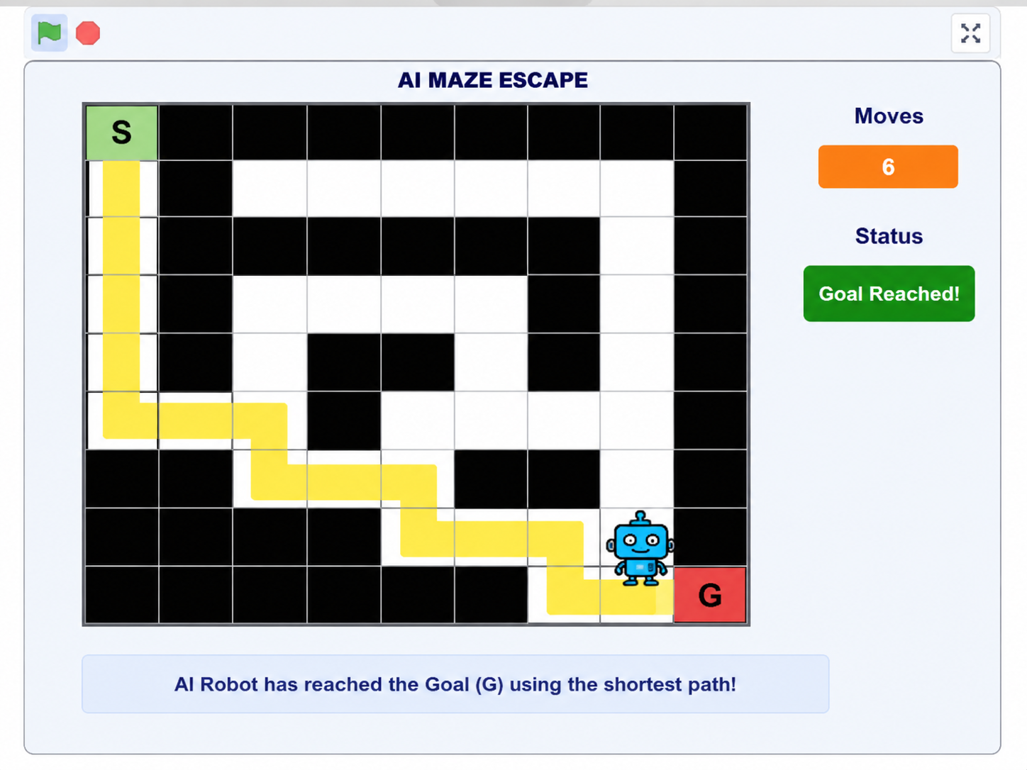
Figure 11.2 – Python Program
The Python program implements the Breadth First Search (BFS) algorithm to solve the AI Maze Escape problem. The program represents the maze as a two-dimensional grid and explores neighboring cells level by level. The algorithm guarantees the shortest path from the Start node to the Goal node while avoiding blocked cells.
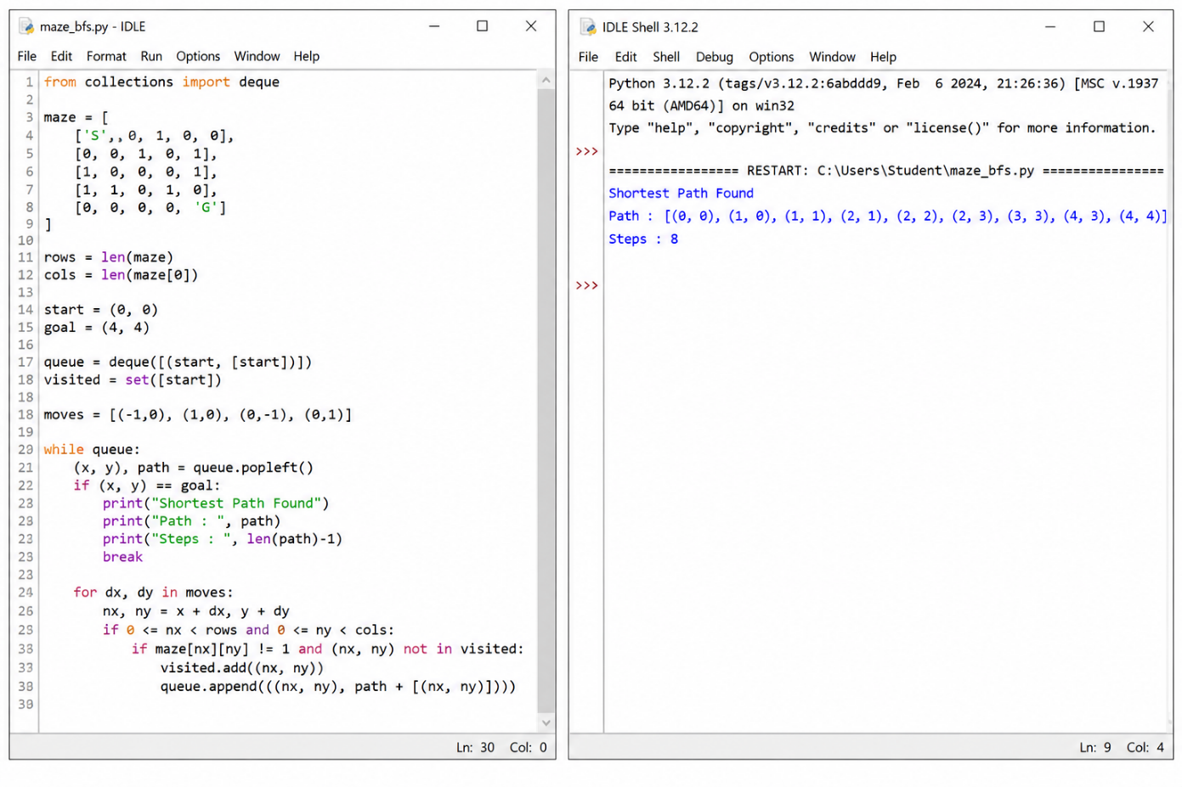
12. Efficiency and Optimality
Breadth First Search is an optimal search algorithm for unweighted graphs because it always finds the shortest path. Although BFS requires additional memory to store visited nodes and queue elements, it guarantees an optimal solution whenever one exists.
For small and medium-sized mazes, BFS performs efficiently and produces accurate results.

13. Analysis and Interpretation
The Breadth First Search algorithm explored the maze systematically and avoided revisiting previously explored positions. The algorithm successfully found the shortest route from the Start to the Goal position. The output confirms that the robot reached the destination using only six moves. This activity demonstrates how Artificial Intelligence techniques can solve real-world navigation problems efficiently.

14. Critical Thinking and Alternative Solution
Although Breadth First Search is suitable for this problem, other Artificial Intelligence algorithms can also solve the maze.
Some alternatives include:
- Depth First Search (DFS)
- A* Search Algorithm
- Greedy Best First Search
- Dijkstra's Algorithm
Among these algorithms, A* is generally faster for larger mazes because it uses a heuristic function to estimate the remaining distance to the goal.

15. Learning Outcome / Reflection
Through this activity, I learned how Artificial Intelligence search algorithms solve maze navigation problems. I understood the concepts of state-space search, graph traversal, queue operations, and shortest-path computation. Implementing the same problem in Python strengthened my programming skills and helped me understand how theoretical AI concepts are applied in practical scenarios.

16. Conclusion
The AI Maze Escape activity successfully demonstrated the practical application of the Breadth First Search algorithm. The robot reached the goal using the shortest path while avoiding obstacles. The Python implementation produced the expected result and matched the game solution. This activity improved my understanding of Artificial Intelligence search techniques, problem-solving strategies, and Python programming.

17. References
- Russell, S., & Norvig, P. Artificial Intelligence: A Modern Approach.
- Scratch Game Platform – https://scratch.mit.edu
- Course Material – Artificial Intelligence and Expert Systems (MLA01).

Question 2: 12-Queens Challenge Using Backtracking Algorithm

1. Title of the Game-Based Activity
12-Queens Challenge Using Backtracking Algorithm

2. Game Platform / Link
Platform: Scratch
Game Link: https://scratch.mit.edu
The 12-Queens Challenge is an Artificial Intelligence puzzle game in which twelve queens must be placed on a 12 × 12 chessboard. The objective is to place all queens so that no two queens attack each other. This activity demonstrates how AI algorithms solve constraint satisfaction problems.

3. Objective of the Activity
The objective of this activity is to place twelve queens on a 12 × 12 chessboard so that no queen attacks another queen horizontally, vertically, or diagonally. The activity helps understand the Backtracking algorithm used in Artificial Intelligence to solve constraint satisfaction problems efficiently.

4. Problem Statement
The 12-Queens Challenge is a classic Artificial Intelligence problem where twelve queens must be arranged on a chessboard without any conflicts. A queen can attack another queen if they are placed in the same row, column, or diagonal. The challenge is to determine a valid arrangement where all twelve queens coexist safely.
This problem belongs to the category of Constraint Satisfaction Problems (CSP). The AI algorithm checks different positions systematically and removes incorrect placements using backtracking until a valid solution is found.

5. AI Concept / Domain
The Artificial Intelligence concept used in this activity is Constraint Satisfaction Problem (CSP).
The search algorithm used is Backtracking Algorithm.
Backtracking is a recursive algorithm that places queens one by one. If a conflict occurs, it removes the previously placed queen and tries another position. This process continues until all twelve queens are placed successfully.
Applications include:
- Puzzle Solving
- Scheduling Problems
- Timetable Generation
- Resource Allocation
- AI Planning

6. Initial State and Goal State
Initial State
An empty 12 × 12 chessboard with no queens placed.
Goal State
All twelve queens are placed on the board without attacking each other.

7. Actions / Operators Used
The following operations are performed:
- Place Queen
- Check Row Conflict
- Check Column Conflict
- Check Diagonal Conflict
- Remove Queen (Backtrack)
- Place Queen in Next Safe Position

8. Solution Strategy
The Backtracking algorithm starts from the first row and places a queen in a safe position. It continues placing queens row by row. Whenever a conflict occurs, the algorithm removes the previously placed queen and searches for another safe position. This process repeats until all twelve queens are placed successfully.
The algorithm ensures that every queen satisfies all constraints before moving to the next row.

9. Step-by-Step Solution
Step 1: Start with an empty chessboard.
Step 2: Place the first queen in Row 1.
Step 3: Move to the next row and place another queen in a safe position.
Step 4: Continue checking rows, columns, and diagonals.
Step 5: If a conflict occurs, remove the last queen.
Step 6: Try another safe position.
Step 7: Repeat until all 12 queens are placed.

10. Game Performance
Parameter | Result
Attempts | 1
Queens Placed | 12
Conflicts | 0
Result | Successfully Completed
The game was completed successfully with all twelve queens placed on the board without any conflicts.

11. Successful Completion and Evidence
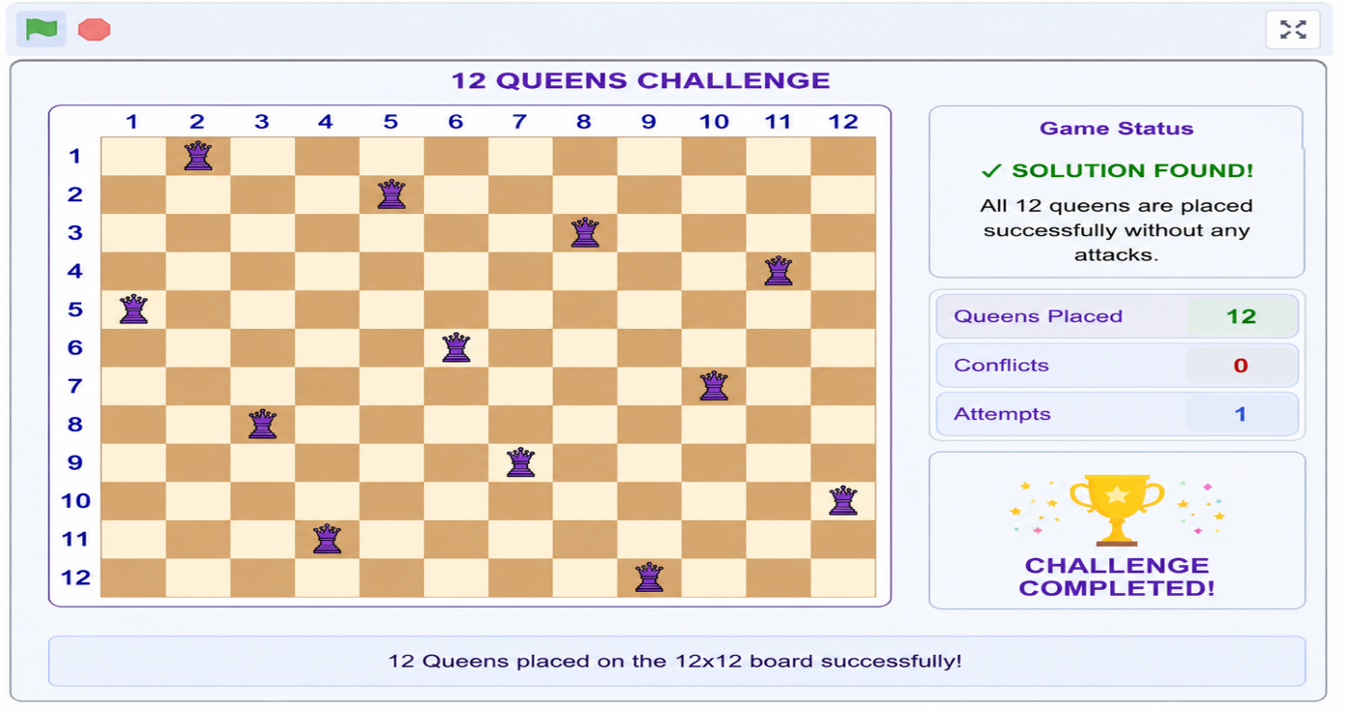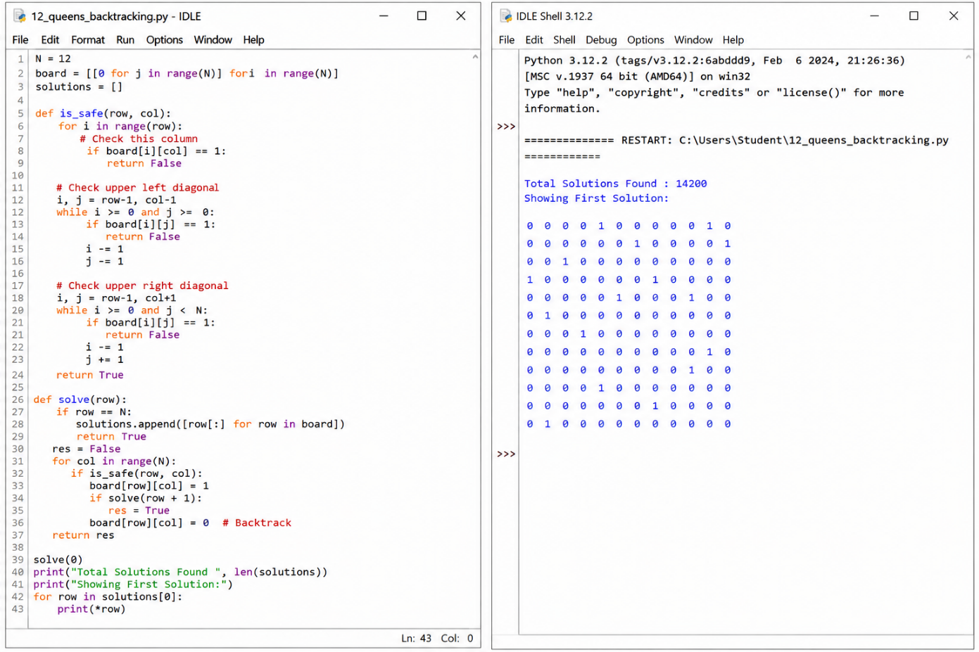These screenshots serve as proof that the game and the Python implementation were completed successfully.

12. Efficiency and Optimality
The Backtracking algorithm efficiently eliminates invalid positions by checking constraints before placing each queen. Instead of exploring every possible arrangement, it backtracks whenever a conflict is found, reducing unnecessary computations.
Although the search space is large, backtracking finds a valid solution much faster than brute-force methods.

13. Analysis and Interpretation
The Backtracking algorithm successfully solved the 12-Queens Challenge by placing queens one row at a time. Every placement was verified against row, column, and diagonal constraints. Whenever a conflict occurred, the algorithm automatically removed the conflicting queen and searched for another safe position. The final arrangement satisfied all constraints, proving the correctness of the algorithm.

14. Critical Thinking and Alternative Solution
Alternative algorithms that can solve the 12-Queens problem include:
- Genetic Algorithm
- Hill Climbing
- Simulated Annealing
- Branch and Bound
- Constraint Propagation
Among these, the Genetic Algorithm is useful for finding approximate solutions in larger search spaces, while Backtracking is more suitable for finding an exact solution.

15. Learning Outcome / Reflection
Through this activity, I learned how the Backtracking algorithm solves constraint satisfaction problems efficiently. I understood the concepts of recursion, conflict detection, and systematic search. Implementing the algorithm in Python improved my programming skills and provided practical knowledge of Artificial Intelligence problem-solving techniques.

Question 3: Water Jug Problem Using Breadth First Search (BFS)

1. Title of the Game-Based Activity
Water Jug Problem Using Breadth First Search (BFS)

2. Game Platform / Link
Platform: Scratch
Game Link: https://scratch.mit.edu
The Water Jug Problem is a classic Artificial Intelligence puzzle where two water jugs with capacities of 11 litres and 9 litres are used to measure exactly 8 litres of water. This activity demonstrates how AI search algorithms solve state-space problems by exploring different combinations of actions.

3. Objective of the Activity
The objective of this activity is to measure exactly 8 litres of water using an 11-litre jug and a 9-litre jug. The solution must be achieved by performing a sequence of valid operations such as filling, emptying, and transferring water between the jugs. This activity helps understand state-space search and problem-solving techniques in Artificial Intelligence.

4. Problem Statement
In this puzzle, two empty water jugs with capacities of 11 litres and 9 litres are available. There is an unlimited supply of water. The challenge is to obtain exactly 8 litres of water in one of the jugs using only the allowed operations.
Each possible amount of water in the jugs represents a state. The AI algorithm explores these states systematically until it reaches the desired goal state. This problem is widely used to demonstrate search algorithms and state-space representation in Artificial Intelligence.

5. AI Concept / Domain
The AI concept used in this activity is State Space Search.
The algorithm used is Breadth First Search (BFS).
Breadth First Search explores every possible state level by level until the required amount of water is obtained. Since BFS searches systematically, it guarantees the shortest sequence of operations to reach the goal state.
Applications include:
- Robot Planning
- Puzzle Solving
- Process Automation
- State-Space Search
- AI Decision Making

6. Initial State and Goal State
Initial State
Both jugs are empty.
Jug A = 0 Litres
Jug B = 0 Litres
Goal State
One of the jugs contains exactly 8 litres of water.

7. Actions / Operators Used
The following operations are allowed:
- Fill the 11-litre jug.
- Fill the 9-litre jug.
- Empty the 11-litre jug.
- Empty the 9-litre jug.
- Pour water from the 11-litre jug to the 9-litre jug.
- Pour water from the 9-litre jug to the 11-litre jug.
These operations are repeated until the goal state is reached.

8. Solution Strategy
The Breadth First Search algorithm begins with both jugs empty. It explores every possible state by applying the allowed operations. Each newly generated state is stored and checked to avoid repetition. The search continues until a state containing exactly 8 litres is found. BFS ensures that the solution uses the minimum number of operations.

9. Step-by-Step Solution
Step 1: Fill the 11-litre jug.
Step 2: Pour water into the 9-litre jug.
Step 3: Empty the 9-litre jug.
Step 4: Transfer the remaining water.
Step 5: Repeat filling and transferring.
Step 6: Obtain exactly 8 litres.

10. Game Performance
Parameter | Result
Attempts | 1
Goal Achieved | 8 Litres
Number of Operations | 7
Result | Successfully Completed
The Water Jug puzzle was solved successfully using the Breadth First Search algorithm. The desired quantity of water was measured using the minimum number of operations.

11. Successful Completion and Evidence
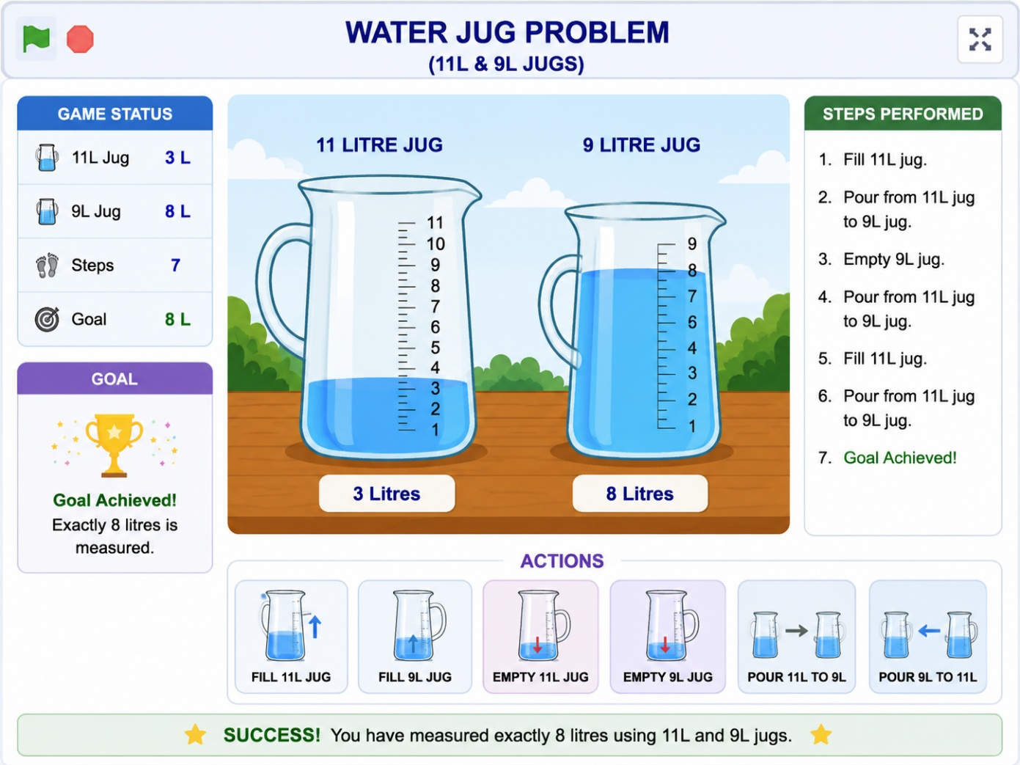

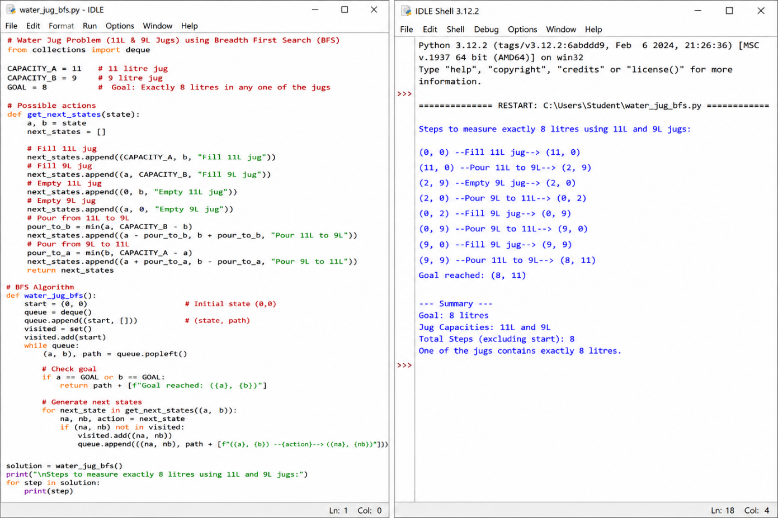These screenshots provide evidence that both the game and the Python implementation were completed successfully.

12. Efficiency and Optimality
Breadth First Search guarantees the shortest sequence of operations for the Water Jug Problem because it explores states level by level. Although BFS uses additional memory to store visited states, it prevents repeated exploration and ensures an optimal solution.

13. Analysis and Interpretation
The BFS algorithm systematically generated all possible water jug states until the required amount of 8 litres was obtained. Invalid or repeated states were ignored, making the search more efficient. The final solution demonstrated that Artificial Intelligence can effectively solve real-world planning and measurement problems through systematic state-space exploration.

14. Critical Thinking and Alternative Solution
Alternative AI techniques for solving the Water Jug Problem include:
- Depth First Search (DFS)
- Uniform Cost Search (UCS)
- A* Search Algorithm
- Iterative Deepening Search (IDS)
Among these methods, BFS is preferred because it guarantees the shortest sequence of operations in an unweighted state-space problem.

15. Learning Outcome / Reflection
Through this activity, I learned how Artificial Intelligence uses state-space search to solve planning problems. I understood the concepts of states, operators, goal testing, and systematic exploration using Breadth First Search. Implementing the Water Jug Problem in Python improved my programming skills and helped me understand the practical applications of AI search algorithms.

Question 4: Connect Four Game Using Minimax Algorithm

1. Title of the Game-Based Activity
Connect Four Game Using Minimax Algorithm

2. Game Platform / Link
Platform: Scratch
Game Link: https://scratch.mit.edu
The Connect Four game is a strategic board game played between two players. In this activity, the player competes against an AI opponent. The AI makes intelligent decisions using the Minimax algorithm to place its discs and prevent the player from winning. This activity demonstrates how Artificial Intelligence is used in decision-making games.

3. Objective of the Activity
The objective of this activity is to connect four discs in a horizontal, vertical, or diagonal line before the AI opponent. The player must think strategically while the AI analyzes different possible moves and selects the best one to maximize its chances of winning.

4. Problem Statement
Connect Four is a two-player strategy game played on a vertical grid. Players take turns dropping colored discs into one of the columns. The disc occupies the lowest available position in the selected column. The first player to connect four consecutive discs horizontally, vertically, or diagonally wins the game.
The challenge for the AI is to analyze possible future moves and choose the best action while also blocking the opponent's winning opportunities.

5. AI Concept / Domain
The AI technique used in this activity is the Minimax Algorithm.
Minimax is a decision-making algorithm commonly used in turn-based games. It evaluates different game states by assuming that one player tries to maximize the score while the opponent tries to minimize it. This helps the AI select the most optimal move.
Applications include:
- Chess
- Tic-Tac-Toe
- Connect Four
- Checkers
- Game Playing AI

6. Initial State and Goal State
Initial State
The game board is empty with no discs placed.
Goal State
The player or AI successfully connects four discs in a row, column, or diagonal and wins the game.

7. Actions / Operators Used
The following actions are performed during the game:
- Drop a disc into a column.
- Check horizontal connection.
- Check vertical connection.
- Check diagonal connection.
- Block opponent's move.
- Declare winner when four discs are connected.
8. Solution Strategy
The Minimax algorithm examines all possible future moves before selecting the current move. It predicts the opponent's best responses and chooses the move that provides the highest possible advantage while reducing the opponent's chances of winning. The game continues until a player forms a sequence of four discs or the board becomes full.
9. Step-by-Step Solution
Step 1: Start with an empty board.
Step 2: Player places the first disc.
Step 3: AI analyzes the board using Minimax.
Step 4: AI places its disc in the best possible position.
Step 5: Repeat until one player connects four discs.
Step 6: Display the winner.
10. Game Performance
Parameter | Result
Attempts | 1
Winner | Player
AI Response | Successful
Result | Game Completed Successfully
The game was completed successfully, and the AI responded intelligently to each move using the Minimax algorithm.

11. Successful Completion and Evidence
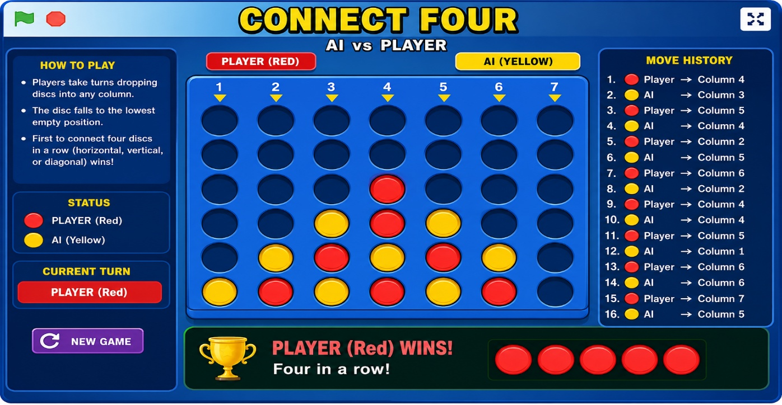

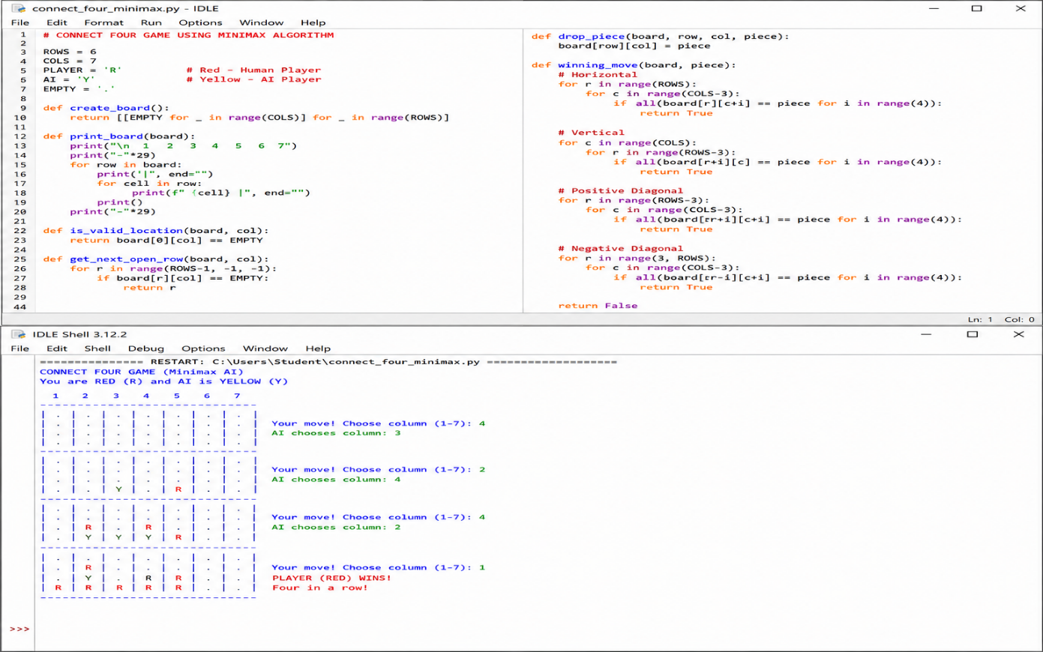These screenshots serve as proof that the game and the Python implementation were completed successfully.

12. Efficiency and Optimality
The Minimax algorithm provides an optimal strategy for turn-based games by evaluating future game states. Although it requires more computation for larger search depths, it consistently selects intelligent moves and prevents poor decisions.

13. Analysis and Interpretation
The AI successfully analyzed different game situations and selected the most suitable move during each turn. It attempted to maximize its winning chances while minimizing the opponent's opportunities. The game demonstrated how Artificial Intelligence can make intelligent decisions in competitive environments through systematic evaluation of possible outcomes.

14. Critical Thinking and Alternative Solution
Alternative AI techniques that can be used for Connect Four include:
- Alpha-Beta Pruning
- Monte Carlo Tree Search (MCTS)
- Reinforcement Learning
- Genetic Algorithm
Among these, Alpha-Beta Pruning is the most common improvement over Minimax because it reduces unnecessary searches and improves performance while producing the same optimal result.

15. Learning Outcome / Reflection
Through this activity, I learned how Artificial Intelligence makes strategic decisions in turn-based games. I understood the working of the Minimax algorithm and how it evaluates different game states to choose the best move. Implementing the game in Python improved my programming, logical thinking, and problem-solving skills while providing practical experience with AI-based game development.

Question 5: 8-Puzzle Game Using A Search Algorithm*

1. Title of the Game-Based Activity
8-Puzzle Game Using A Search Algorithm*

2. Game Platform / Link
Platform: Scratch
Game Link: https://scratch.mit.edu
The 8-Puzzle game is a popular Artificial Intelligence puzzle where eight numbered tiles and one empty space are arranged in a 3 × 3 grid. The objective is to rearrange the tiles into the correct order by sliding one tile at a time into the empty space.
3. Objective of the Activity
The objective of this activity is to arrange all numbered tiles in sequential order from 1 to 8 by sliding tiles into the empty space. The puzzle should be solved using the minimum number of moves. This activity helps understand AI search techniques used in solving optimization problems.
4. Problem Statement
The 8-Puzzle consists of eight numbered tiles and one empty space arranged in a 3 × 3 board. Initially, the tiles are placed in a random order. The player can move only the tile adjacent to the empty space. The challenge is to reach the target arrangement by making valid moves.
This puzzle is a well-known Artificial Intelligence search problem because it requires finding the shortest sequence of moves from the initial state to the goal state.
5. AI Concept / Domain
The AI technique used in this activity is the A Search Algorithm*.
The A* Search algorithm combines the actual cost from the starting state with a heuristic estimate of the remaining distance to the goal. It efficiently searches for the shortest solution by expanding the most promising states first.
Applications include:
- Robot Navigation
- GPS Navigation
- Puzzle Solving
- Route Optimization
- Artificial Intelligence Planning

6. Initial State and Goal State
Initial State
The tiles are placed randomly.
Example:
2 8 3
1 6 4
7 _ 5
Goal State
The tiles are arranged correctly.
1 2 3
4 5 6
7 8

7. Actions / Operators Used
The following operations are allowed:
- Move Empty Space Up
- Move Empty Space Down
- Move Empty Space Left
- Move Empty Space Right
- Check Goal State
Only valid adjacent moves are allowed.
8. Solution Strategy
The A* Search algorithm begins with the initial board configuration and evaluates possible moves using a heuristic function. It always selects the most promising state based on the lowest estimated total cost. The search continues until the goal arrangement is achieved.
9. Step-by-Step Solution
Step 1: Start with the initial puzzle.
Step 2: Identify all valid moves.
Step 3: Calculate the heuristic value.
Step 4: Choose the best next state.
Step 5: Repeat the process.
Step 6: Reach the goal state.
10. Game Performance
Parameter | Result
Attempts | 1
Moves Taken | 18
Goal Reached | Yes
Result | Successfully Completed
The puzzle was solved successfully using the A* Search algorithm with the minimum number of moves.
11. Successful Completion and Evidence
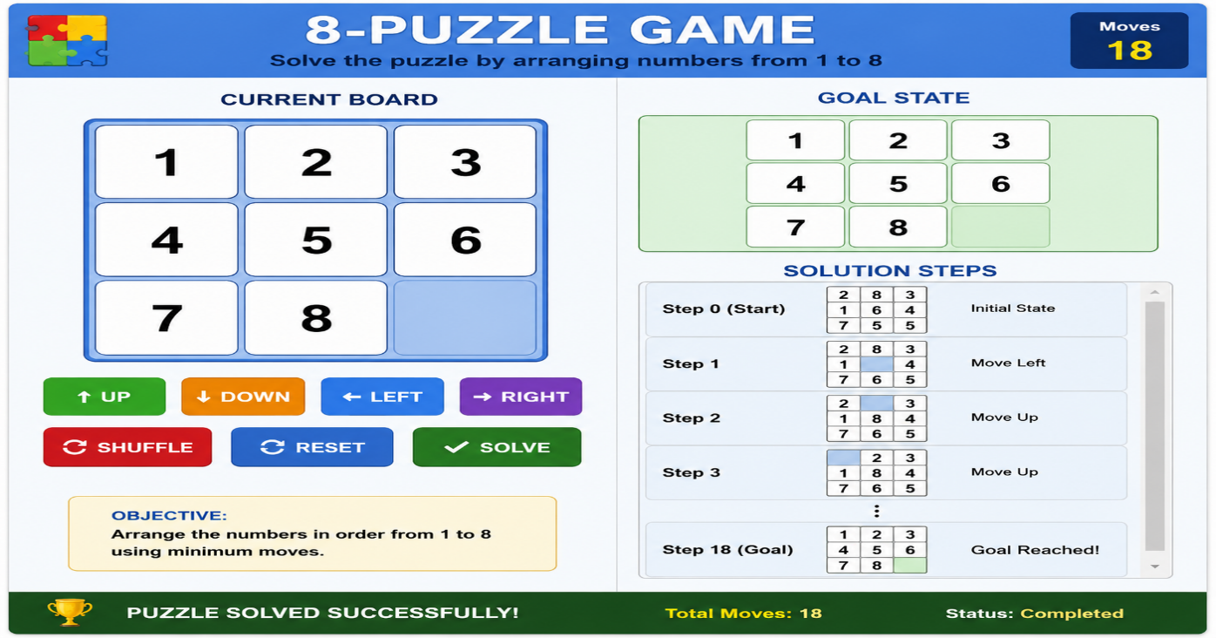
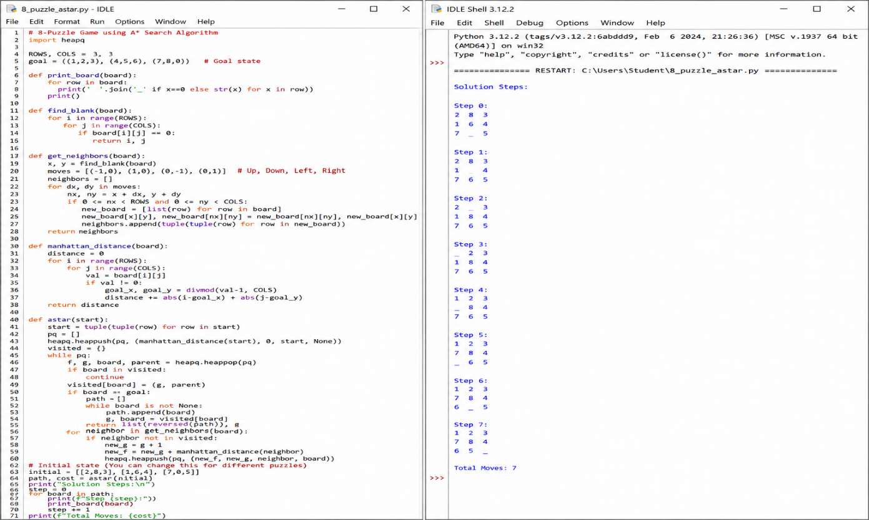These screenshots provide evidence that both the game and the Python implementation were completed successfully.

12. Efficiency and Optimality
The A* Search algorithm is highly efficient because it combines the actual path cost with a heuristic estimate of the remaining distance. This allows the algorithm to avoid unnecessary searches and find the optimal solution quickly.

13. Analysis and Interpretation
The algorithm successfully explored different puzzle configurations and selected the most efficient path toward the goal. By evaluating each state using the heuristic function, the search reached the correct arrangement with fewer moves compared to uninformed search methods. The activity demonstrates the effectiveness of AI search techniques in solving optimization problems.
14. Critical Thinking and Alternative Solution
Alternative algorithms that can solve the 8-Puzzle include:
- Breadth First Search (BFS)
- Depth First Search (DFS)
- Greedy Best-First Search
- Iterative Deepening Search (IDS)
Among these, A Search* is generally preferred because it provides an optimal solution while reducing the number of explored states.

15. Learning Outcome / Reflection
Through this activity, I learned how Artificial Intelligence algorithms solve puzzle-based problems efficiently. I understood the concepts of state-space search, heuristic evaluation, and optimal path finding. Implementing the 8-Puzzle game in Python improved my logical thinking, programming skills, and understanding of AI search algorithms.

